CALIFORNIA CITRUS NURSERY BOARD

PROJECT PLAN

Fiscal Year: 2018 Duration of Project: 3 Years + 2 years, 5 years
*Note: Year 4 & 5 required to complete the screenhouse experiment.

This project is: Continuing, year 5 of 5

Project Leader: Georgios Vidalakis¹ and Fatima Osman²
Location/Department:
1. Department of Plant Pathology & Microbiology, University of California, Riverside, CA 92521. Phone: (951) 827-3736, FAX: (951) 827-4294, E-mail:vidalg@ucr.edu
2. Department of Plant Pathology, University of California, Davis, CA 95616, Phone: (530) 752-2942, E-mail: fmosman@ucdavis.edu

Collaborators:
1. Maher Al Rwahnih, Department of Plant Pathology, University of California, Davis, CA 95616, Phone: (530) 752-2942, E-mail: malrwahnih@ucdavis.edu
2. Rock Cristiano, Department of Plant Pathology & Microbiology, University of California, Riverside, CA 92521-Lindcove Research and Extension Center, Exeter, CA 93221. Phone: (559) 429-9718, E-mail:rock.christiano@ucr.edu
3. Sohrab Bodaghi Department of Plant Pathology & Microbiology, University of California, Riverside, CA 92521. Phone: (951) 827-4932, FAX: (951) 827-4294, E-mail: sohrab.bodaghi@ucr.edu
4. Irene Lavagi, Department of Plant Pathology & Microbiology, University of California, Riverside, CA 92521. Phone: (951) 827-4932, FAX: (951) 827-4294, E-mail: irene.lavagi@ucr.edu

Project Title: Implementation and streamlining of the newly developed high throughput diagnostic system for citrus nurseries registration.

______________________________________________________________________________

Executive Summary
The Citrus nurseries depend on their disease-tested scion and seed sources for the propagation of high quality nursery trees. In California, the Citrus Clonal Protection Program (CCPP) has been responsible for the development and execution of the registration program of nursery owned citrus source trees for many years. The CCPP has been constantly trying to improve the testing of source trees and upgrade its diagnostic platform given the available technologies. The registration program began with biological indexing, it was later enhanced with ELISA and Imprint Hybridization, and today we are moving towards the universal, molecular, real time, high throughput detection of citrus regulated pathogens. In doing so, the CCPP is providing high quality services to the industry under the auspices and commitment to the CCNB mission in a timely and economical manner and thus fulfilling its mission under the new mandatory “Citrus Nursery Stock Pest Cleanliness Program” program.
The development and validation of the universal/multiplex detection methods has been completed at the laboratory level with the CCNB funded project “The Future of the Cooperative Registration Program of Nursery Owned Citrus Source Trees”. Now it is time for the implementation of the developed methods in a large scale at the industry level. There are a few basic questions that need to be resolved for the successful, economical, practical, and timely implementation of the new diagnostic methods.
- Streamlining and minimizing the chance for false results of the viroids, RNA viruses, and DNA pathogens developed methods.
- Optimizing the time and frequency of sampling in regard to time of the year, temperature, and tree phenological stage.
- Building a cohesive efficiently working system of sample collection, tracking, and processing, record keeping, data management, and results reporting.

In this proposal, we intend to incorporate the three high throughput detection assays into a routine workflow, starting from optimum time for sample collection, processing, multiplex detection of RNA and DNA pathogens, tracking each sample from start to finish, documenting and timely reporting of the results. We believe that optimizing and fine-tuning the system as a whole it will reduce time and cost as well as offering flexibility for the future direction of a certification program for citrus nursery stock.

Keywords: Disease-tested propagating material, pathogen detection, multiplex Reverse transcription real time quantitative polymerase chain reaction (RT-qPCR), qPCR, Time course, Laboratory Information Management System
______________________________________________________________________________

Benefit to the Industry
Citrus is a perennial crop susceptible to many graft transmissible disease agents including at least nine arthropod transmitted pathogens (Roistacher, 1991), threatening citrus production worldwide (Bar-Joseph et al., 1989; Bovè, 2006). This makes co-infection of a citrus tree by two or more pathogens common. The worst citrus diseases include stem pitting of Citrus tristeza virus (CTV) and Huanglongbing (HLB), also known as citrus greening or yellow shoot disease (Bar-Joseph et al., 1989; Timmer et al., 2000; Bovè, 2006). Therefore, efficient high throughput multiplex qPCR based diagnostic tests are needed for these and other citrus pathogens to maintain a vigorous citrus industry.
Since a number of these important citrus pathogens are spread by propagation, arthropod vectors and inadvertent import and dissemination of infected plants, citrus disease management and clean stock programs require economical, reliable, high throughput pathogen detection systems in order to maintain a productive, competitive, and sustainable industry.
To this end, developing a complete workflow and optimum use of resources for reliable pathogen detection is key for the industry. Each component of the existing testing program needs to be optimized, fine-tuned and coordinated for efficiency, cost, and time reduction so it can set the platform for a future citrus nursery certification program. Concerns expressed among citrus industry members for the cost, sample collection and testing frequency, practical business consequences of false results, and timely reporting of testing results are justified. The proposed timeline experiment for optimum time of sample collection, deep sequencing of citrus pathogens for “hidden” genetic variation that may affect the accuracy of qPCR, and the incorporation of a Laboratory Information Management System (LIMS) for accurate sample tracking and documentation, and timely results reporting will address many of these concerns.
Finally, a well-functioning, optimized, cost effective system for testing the nursery budwood and seed source plants will open the road for the establishment of a complete certification scheme of citrus nursery stock that will facilitate the marketing of disease-certified nursery products for the local, national, and international markets.
______________________________________________________________________________

Objectives
The objectives of this proposal aim on the implementation and streamlining of a complete, reliable, high throughput diagnostic system-from sample collection to results reporting-for citrus nursery regulated pathogens. Objectives can be summarized as follows;
- Streamlining and minimizing the chance for false results of the viroids, RNA viruses, and DNA pathogens developed methods.
- Optimizing the time and frequency of sampling in regard to time of the year, temperature, and tree phenological stage.
- Building a cohesive efficiently working Laboratory Information Management System (LIMS) for sample collection, tracking, and processing record keeping, data management, and results reporting.
_____________________________________________________________________________

Work plans & Methods
- Streamlining and minimizing the chance for false results of the viroids, RNA viruses, and DNA pathogens developed methods. - Completed
Three universal/multiplex assays have been developed (CCNB-The Future of the Cooperative Registration Program of Nursery Owned Citrus Source Trees) for the detection of citrus nurseries regulated pathogens:
a) Universal detection of citrus viroids: Citrus exocortis viroid, Hop stunt viroid, Citrus bark cracking viroid, Citrus bent leaf viroid, Citrus dwarfing viroid, Citrus viroid V (CVd-V) and CVd-VI.
b) Multiplex detection of RNA viruses: Citrus tristeza virus, Citrus psorosis virus (CPsV), and Citrus leaf blotch virus (CLBV) (Osman et al., 2015).
c) Multiplex detection of DNA pathogens: Candidatus Liberibacter sp. (asiaticus, americanus, africanus) and Spiroplasma citri. – Note: This year we will finalize analyses of deep sequence data for S. citri
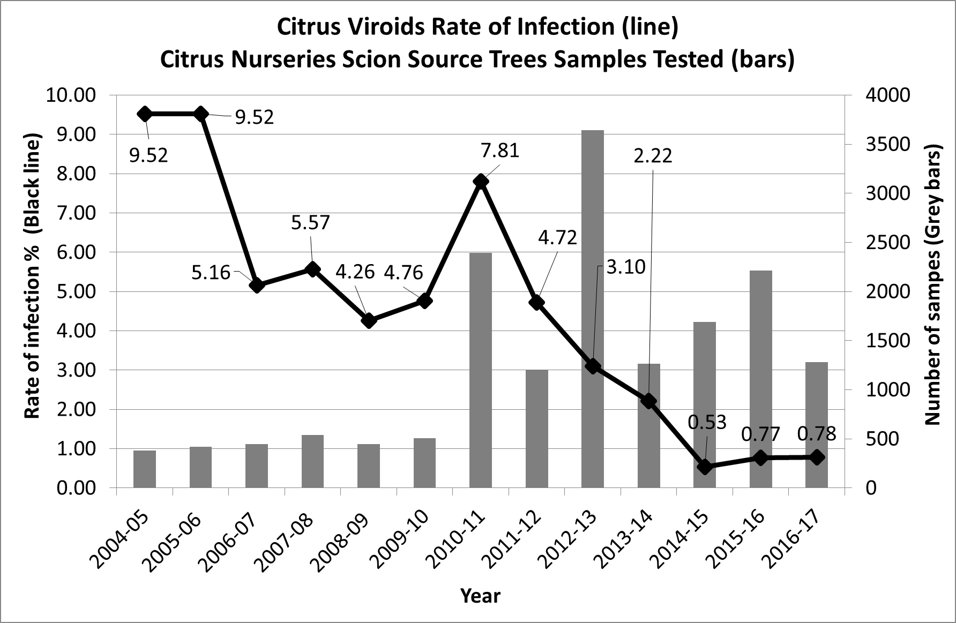
These three assays will be streamlined for a rapid, high throughput, low cost qPCR based diagnostic protocol. Multiplex qPCR detection will be performed using the QuantStudio™ 12K high throughput detection instrument.
The benefits to the registration program from the use of just one of the newly developed methods i.e. universal detection of citrus viroids (Vidalakis and Wang 2013) since 2001-11 (see figure) are already visible. The testing capacity of the registration program has increased dramatically (grey bars). As a result a trend of reduced viroid infection is developing (black line). In other words, during the years of biological indexing (2005-2010) the number of samples tested was limited. As a result the program was always behind the curve and the viroid infection was maintained stable. From the 2010 forward and with the number of samples tested dramatically increased the program is getting ahead of the curve and the viroid infection has moved downwards (0.5-0.8% in 2014-17 testing cycles). If the trend continues and the combination with best management nursery practices the frequency or individual tree testing (i.e. sample pooling) can be modified and eventually the cost for viroids testing can be reduced. When all three high throughput methods are harmonized and streamlined the benefits to the industry will be maximized.

- Optimizing the time and frequency of sampling in regard to time of the year, temperature, and tree phenological stage. – To be completed in years 4 & 5
Heterogeneous distribution, low concentration and seasonal titer variations of pathogens in citrus are main problems for the implementation of molecular biology-based laboratory detection protocols. Detection of the citrus pathogens is influenced by factors that affect concentration as the erratic distribution within the plant (Lee et al, 2001; D'Urso et al., 2000), the type and age of tissue used for analysis, the season (Lee et al., 2001), mixed infections, and environmental factors.
A time course study will be performed for at least 24 months with regular sampling intervals to evaluate the pathogen titer in different seasons within the period of vegetative growth throughout a range of temperatures.
In spring 2015 we received from the CCPP Foundation Operations at the Lindcove Research and Extension Center 260 trees of navel orange, mandarin, satsuma, lemon and grapefruit and established them (e.g., set up of growth benched, irrigation lines, labelling etc.) at the CCPP Quarantine Screenhouse. In addition, we developed sources of inoculum for the CDFA regulated pathogens in the citrus nursery stock pest cleanliness program (e.g. CTV, CPsV, S. citri, and citrus viroids), and designed a replicated experiment for mix infections of these pathogens.
In winter 2016, in order to avoid the high summer temperatures, we executed the mix infection experiment (fig. 1). The trees were tested prior to inoculation for the presence of graft-transmissible pathogens.

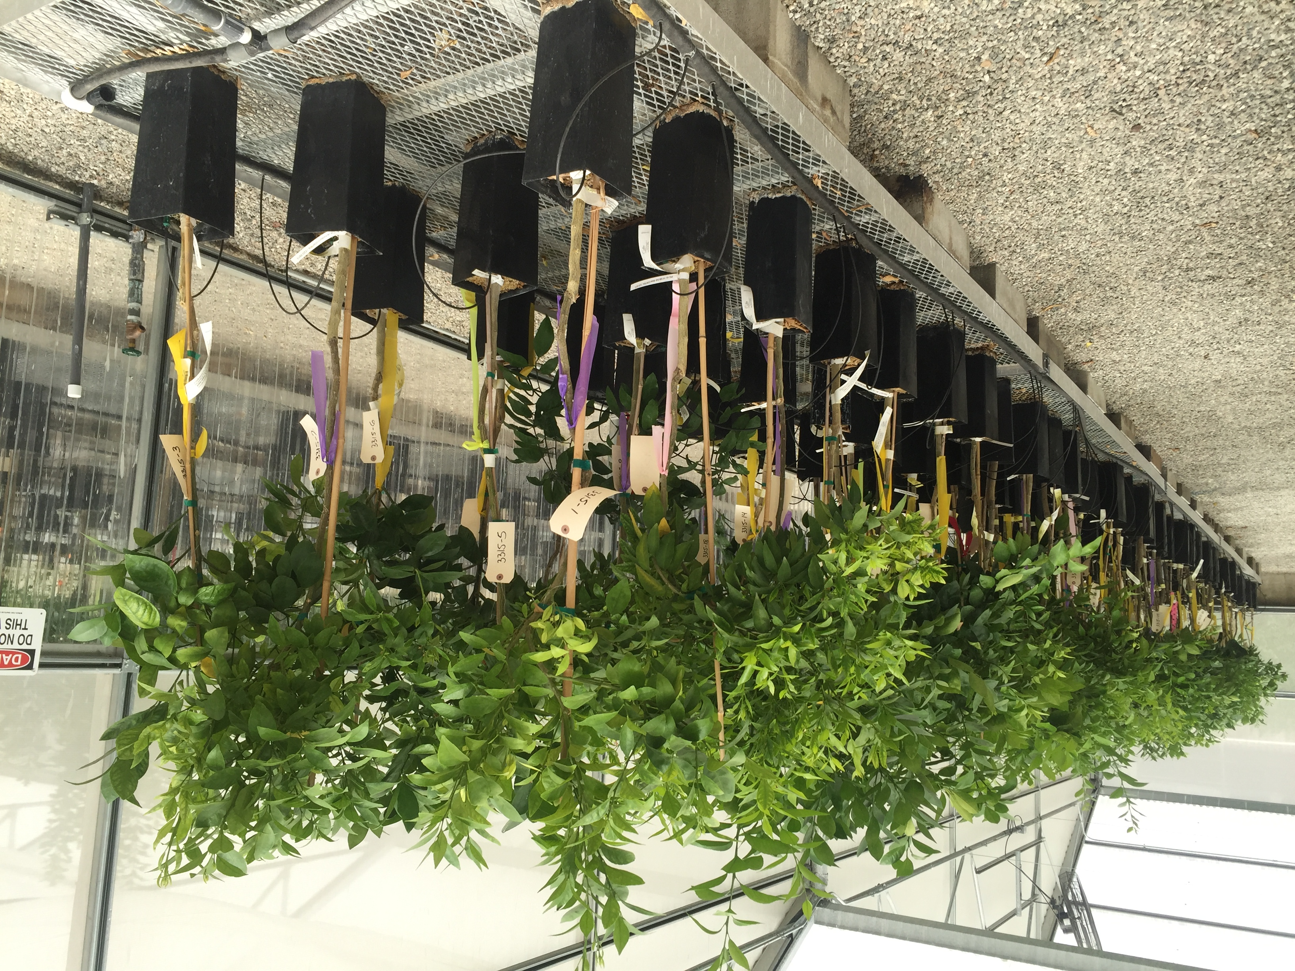
352 inoculated citrus trees. Tape color and pattern indicated different citrus species and treatments (see table 1 below).

Table 1. Screenhouse experiment for optimizing the time and frequency of sampling in regard to time of the year, temperature, and tree phenological stage.
Flag Color | Citrus Species - Swingle | Count
Black | Citrus aurantifolia | 13
Blue | C. aurantium L. | 4
Fluorescent Yellow | C. hybrid-C. maxima (Burm.) Merr. X C. reticulata Blanco | 12
Green | C. limon (L.) Burm.f. | 12
Orange | C. paradisi Macf.-Grapefruit | 12
Pink | C. reticulata Blanco-Clementine | 29
Purple | C. reticulata Blanco-Mandarin | 68
Red | C. reticulata Blanco-Satsuma | 29
White | C. reticulata Blanco-Tangor | 4
Yellow | C. sinensis (L.) Osb.-Navel | 91
Black Dots / Pink | C. sinensis (L.) Osb.-Sweet orange | 8
Orange dots / White | C. sinensis (L.) Osb.-Valencia | 7
Red Dots / Yellow | Citroncirus J.W. Ingram & H.E. Moore | 45
No Flag | C. hybrid- C. reticulata Blanco X C. tangelo J.W. Ingram & H.E. Moore | 1
No Flag | C. maxima (Burm.) Merrill. | 2
No Flag | C. medica L. | 2
No Flag | C. paradisi Macf.-Pummelo | 1
No Flag | C. sinensis (L.) Osb.-Blood orange | 2
No Flag | C. sinensis (L.) Osb.-Tangor | 1
No Flag | C. tangelo J.W. Ingram & H.E. Moore | 2
No Flag | Fortunella margarita (Lour.) Swingle | 2
No Flag | X Citrofortunella sp. | 2
No Flag | X Citroncirus spp.-1 | 1
No Flag | X Citroncirus spp.-2 | 1
No Flag | X Citrondarin spp. | 1
 | Total | 352

Treatment Code | Treatment | Treatment-Full name | Flag Pattern | Flag Color
1 | H | Healthy-Not-inoculated | Striped | Yellow / Black
2 | CTV | Citrus tristeza virus (CTV) | Striped | Blue / White
3 | Ps | Citrus psorosis virus (CPsV) | Striped | Green / Black
4 | LB | Citrus leaf blotch virus (CLBV, Dweet mottle) | Striped | Green / White
5 | Sc | Spiroplasma citri | Striped | Orange / Black
6 | Vds | Citrus viroid mix (8-14) | Striped | Red / Black
7 | ALL | All pathogens (1-6) | Striped | White / Black
8 | CEVd | Citrus exocortis viroid (CEVd) | Checkered | White / Black
9 | Ia | Citrus bent leaf viroid (CBLVd, CVd-Ia) | Checkered | Blue / Black
10 | IIa | Hop stunt viroid (HSVd, CVd-IIa, non-cachexia) | Checkered | Blue / White
11 | IIb | Hop stunt viroid (HSVd, CVd-IIb, cachexia) | Checkered | Green / Black
12 | IIIb | Citrus dwarfing viroid (CDVd, CVd-IIIb) | Checkered | Orange / White
13 | IV | Citrus bark cracking viroid (CBCVd, CVd-IV) | Checkered | Pink / White
14 | V | Citrus viroid V (CVd-V) | Checkered | Red / Black
15 | VI | Citrus viroid VI (CVd-VI) | Checkered | Red / White

In spring 2017, we collected the first set of samples including bark, leaf petioles and newly emerged flush, from the non-inoculated and mixed inoculated controls for viruses and viroids in order to confirm pathogen establishment. We also monitored temperatures inside the protective structure 24 hours a day.
This year, we will re-inoculate any plants identified from the 2017 sampling as non infected. In addition, we will collected samples at specific time intervals representing different citrus flushing stages. More specifically, we will allow 12 weeks intervals for citrus growth and collect at 4 different time points in February, May, August and November (see sketch below). We will continue monitoring temperatures 24 hours a day.
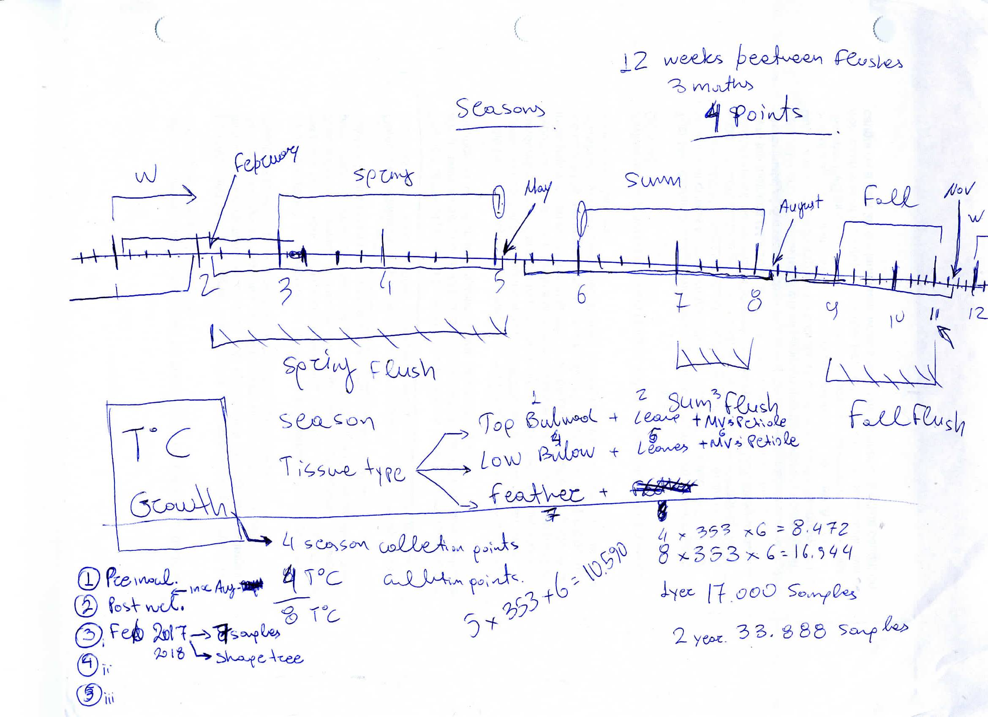
The tens of thousands of samples (sketch above) will be processed with the high throughput semi-automated nucleic acid extraction system approved by CDFA and tested with the developed singleplex and multiplex qPCR and RT-qPCR (see objective 1). Due to the large scale and complexity of this experiment, we have encountered several unforeseen delays but we will continue working systematically and we will collect the critical information that will help the citrus nurseries to operate confidently within the new CDFA registration system.
After the preliminary data analysis indicate a specific time period, temperature range, or phenological tree stage that is preferable for pathogen detection we can evaluate the performance of our protocols on citrus nursery regulated pathogens exotic to California. For example, if our data indicate that temperatures 25-28ºC are optimum for sample collection and testing of CTV, CPsV and viroids we can contact fellow scientists in Florida and request nucleic acid extracts or lyophilized tissues of trees infected with C. Liberibacter asiaticus and CLBV collected at that temperature range so we can test all our protocols.

- Building a cohesive efficiently working Laboratory Information Management System (LIMS) for sample collection, tracking, and processing record keeping, data management, and results reporting. - Completed
In 2016, we proceeded with the evaluation of the different products in regard to annual cost, functionality for the current and future needs of the program, and alignment with regulatory requirements. This objective is also supported by the Citrus Research Board and the National Clean Plant Network.
In 2017, we concluded that Autoscribe was the best fit for the CCPP and we complete the purchase. We also had several meetings with Autoscribe and UC Riverside in order to streamline the installation of the software in the campus servers. Subsequently we initiated hands on training and customization of the LIMS system for the CCPP functions including the processing and testing of the citrus nursery samples.

This year we will continue with customization for all the different laboratory and greenhouse functions and proceed with Beta trial of the system. In addtion, we will continue our discussions with Autoscribe for the expansion of LIMS to include the Quality Management suite for the completion of the STAR-D accreditation (equivalent to ISO) for the CCPP diagnostic laboratory.

Table 2. Laboratory Information Management System (LIMS) vendors and descriptions
Vendor | Description
Autoscribe | Full Matrix Gemini, Instrument Calibration and Maintenance Module, Integrated Competency Manager module, Stand-alone, single-user Competency Management module, Crystal Reports Professional Edition, on-site to finalize detailed requirements, project management, finalize setup & install; 3 users
______________________________________________________________________________

Project Management and Evaluation
Dr. Georgios Vidalakis is the Director of CCPP and has long experience with pathogen detection and management in citrus germplasm. He is working closely with the researchers of this project.
Dr. Fatima Osman is an assistant project scientist at the University of California Davis with an appointment in the CCPP at the University of California, Riverside and she is one of the two administrative coordinator of the National Clean Plant Network for Citrus. Her main research work focuses on the design of novel sensitive detection techniques of Citrus pathogens. Dr. Osman has more than twelve years’ experience in developing advanced real-time quantitative RT-qPCR singleplex and multiplex assays for the detection of grapevines, fruits and citrus.
Dr. Sohrab Bodaghi is an associate research scientist with CCPP at the University of California Riverside. Dr. Bodaghi has more than 15 years' experience in Microbiology and Plant Pathology fields with expertise in general, molecular and plant virology. He has been involved with regulated pathogens laboratory testing (dsRNA, sPAGE, RT-qPCR) of quarantined citrus varieties and thousands of samples from nursery as well as CCPP’s citrus germplasm sources for commercial use.
Dr. Maher Al Rwahninh has extensive experience using Next Generation Sequencing (NGS) in identifying pathogens strains, and will be instrumental in processing samples for NGS, as well as analyze the vast sequencing information derived from the Bioinformatic analysis to screen for proper pathogen’s sequence required for designing the multiplex qPCR assays.
Dr. Irene Lavagi is an assistant project scientist with CCPP at the University of California Riverside and she is one of the two administrative coordinator of the National Clean Plant Network for Citrus. Dr. Lavagi is the quality manager for the CCPP and she has been managing scientific laboratories including coordinating (i.e. databases, websites, etc.) large groups of scientists in different institutions and countries since 2009.

Budget Proposal

Project Title: Implementation and streamlining of the newly developed high throughput diagnostic system for citrus nurseries registration.

Project Leaders: Georgios Vidalakis and Fatima Osman

Proposed Fiscal Year: 2018

A. PERSONNEL SERVICES:
Assistant Project Scientist @ 50% $34,601
Benefits 42.6% $14,739

TOTAL PERSONNEL SERVICES $49,340

B. OPERATING EXPENSES:
Laboratory Supplies (kits, sequencing, etc.) $12,000
Travel $ 1,500

C. TOTAL OPERATING EXPENSES: $13,500

D. TOTAL BUDGET REQUESTED: $62,840


____________________________________________________________________________

Signatures of Requestors: Date: 11-06-17

Date: _________

Signature of Cooperator: Date: _________

Department Chair: Date: _________

LIAISON OFFICER Date

Literature Review
- Ananthakrishnan, G., Venkataprasanna, T., Roy, A., &Brlansky, R. H. 2010. Characterization of the mixture of genotypes of a Citrus tristeza virus isolate by reverse transcription-quantitative real-time PCR. J. Virol. Methods 164, 75-82.
- Bar-Joseph, M., Marcus, R. & Lee, R. F. 1989. The continuouschallenge of citrus tristeza virus control. Annual Review of Phytopathology27, 291-316.
- Bové, J. M. 2006. Huanglongbing: A destructive, newly-emerging, century-old disease of citrus. J. Plant Pathol. 88, 7-37.
- Bertolini, E., A. Moreno, N. Capote, A. Olmos, A. de Luis, E. Vidal, J. Pérez-Panadés and M. Cambra. 2008. Quantitative detection of Citrus tristeza virus in plant tissues and single aphids by real-time RT-PCR. European Journal of Plant Pathology 120, 177-188.
- .D'Urso, F., Ayllón M.A., Rubio, L., Sambade, A., Hermoso de Mendoza A., Guerri, J., Moreno, P. 2000. Contribution of uneven distribution of genomic RNA variants of citrus tristeza virus (CTV) within the plant to changes in the viral population following aphid transmission. Plant Pathology 49, 288-294.
- Hilf M. & Garnsey S. 2000. Characterization and classification of citrus tristeza virus isolates by amplification of multiple molecular markers. Proceedings of 14th IOCV. pp 18-27.
- Hilf M. E., Mavrodieva V. A., & Garnsey S. M. 2005. Genetic marker analysis of a global collection of isolates of Citrus tristeza virus: Characterization and distribution of CTV genotypes and association with symptoms. Phytopathology95, 909-917.
- Kim JS, Wang N. 2009. Characterization of copy numbers of 16S rDNA and 16S rRNA of Candidatus Liberibacter asiaticus and the implication in detection in planta using quantitative PCR.BMC Res. Notes6, 2-37.
- Lee, R.F., Garnsey, S. M., Marais, L. J., Moll, J. N., Youtsey, C. 0. 2001. Distribution of Citrus Tristeza Virus in Grapefruit and Sweet Orange in Florida and South Africa Issue Plant Pathology 49, 288-294.
- Li W., J. S. Hartung, L. Levy. 2006. Quantitative real-time PCR for detection and identification of Candidatus Liberibacter species associated with citrus huanglongbing. J. Virol. Methods 66, 104-115.
- Li W., Hartung J.S., Levy L. 2007. Evaluation of DNA amplification methods for improved detection of “Candidatus Liberibacter species” associated with citrus huanglongbing. Plant Disease 91, 51-58.
- Loconsole, G., Saponari, M. and Savino, V., 2010. Development of real-time PCR based assays for simultaneous and improved detection of citrus viruses. European Journal of Plant Pathology 128, 251-259.
- Loconsole, G., Onelge, N., Yokomi, R., AbouKubaa, R., Savino, V., Saponari, M. 2013. Rapid differentiation of Citrus Hop Stunt viroid variants by real-time RT-PCR and high resolution melting analysis. Molecular and Celullar Probes 27, 221-229.
- Marbot S., Salmon M., Vendrame M., Huwaert A., Kummert J., Dutrecq O., Lepoivre P., 2003. Development of real-time RT-PCR assay for detection of Prunus necrotic ringspot virus in fruit trees. Plant Disease 87, 1344-1348.
- Manjunath KL, Halbert SE, Ramadugu C, Webb S, Lee RF. 2008. Detection of 'Candidatus Liberibacter asiaticus' in Diaphorina citri and its importance in the management of citrus huanglongbing in Florida. Phytopathology 98, 387-96.
- Mathews, D.M., Riley, K. and Dodds, J.A., 1997. Comparison of detection methods for citrus tristeza virus in field trees during months of nonoptimal titer. Plant disease 81, 525-529.
- Morgan, J. K., Zhoub, L., Lic, W., Shattersa, R. G., Keremaned, M., Duan Y-P. 2012. Improved real-time PCR detection of ‘Candidatus Liberibacter asiaticus’ from citrus and psyllid hosts by targeting the intragenic tandem-repeats of its prophage genes. Molecular and Cellular Probes 26, 90-98.
- Osman, F., Hodzic, E. Kwon, S-J. Wang, J. Vidalakis, G. 2013a. Development and validation of a multiplex reverse transcription quantitative PCR (RT-qPCR) assay for the rapid detection of Citrus tristeza virus, Citrus psorosis virus, and Citrus leaf blotch virusCTV, CLBV and CPsV multiplex. J. Virol. Methods. Under review.
- Osman, F., Al Rwahnih, M., Rowhani A. 2013b. Improved Detection of Ilarviruses and Nepoviruses affecting Fruit Trees using quantitative RT-qPCR. Journal of Plant Pathology. in Press.
- Osman F., Olineka T., Hodzic E., Golino D., Rowhani A., 2012a. Comparative Procedures for Sample Processing and Quantitative PCR Detection of Grapevine Viruses. J. Virol. Methods 179, 303-310.
- Osman F., Al Rwahnih M., Golino D., Pitman T., Cordero F., PreeceJ.E., Rowhani A., 2012b. Evaluation of the Phytosanitary Status of the Prunus Species in the National ClonalGermplasm Repository in California: Survey of Viruses and Viroids. Journal of Plant Pathology 94, 249-253.
- Osman F., Rowhani A., 2008. Real-time RT-PCR (TaqMan®) assays for the detection of viruses associated with Rugose wood complex of grapevine. J. Virol. Methods 154, 69–75.
- Osman F., Leutenegger C., Golino D., Rowhani A., 2007. Real-time RT-PCR (TaqMan®) assays for the detection of Grapevine Leafroll associated viruses 1–5 and 9. J. Virol. Methods 141, 22-29.
- Osman F., Rowhani A., 2006. Application of a spotting sample preparation technique for the detection of pathogens in woody plants by RT-PCR and real-time PCR (TaqMan). J. Virol. Methods 133, 130-136.
- Roistacher, C.N., 1991. Graft-transmissible diseases of citrus: handbook for detection and diagnosis. Food & Agriculture Org.
- Rosa, C., Polek, M., Falk, B. W., Rowhani, A. 2007. Improved efficiency for quantitative and qualitative indexing for Citrus tristeza virus and Citrus psorosis virus. Plant Disease 91, 1089-1095.
- Ruiz-Ruiz, S., Moreno, P., Guerri, J., and Ambrós, S. 2009a. Discrimination between mild and severe Citrus tristeza virus isolates with a rapid and highly specific real-time reverse transcription-polymerase chain reaction method using TaqMan LNA probes. Phytopathology 99, 307–315.
- Ruiz-Ruiz S., S. Ambros, M. C. Vives, L. Navarro, P. Moreno, J. Guerri. 2009b. Detection and quantitation of Citrus leaf blotch virus by TaqMan real-time RT-PCR. J. Virol. Methods 160, 57-62.
- Ruiz-Ruiz, S., Moreno, P., Guerri, J., Ambrós, S. 2007. A real-time RT-PCR assay for detection and absolute quantitation of Citrus tristeza virus in different plant tissues.J. Virol. Methods 145, 96-105.
- Saponari, M., Loconsole G., Liao, H-H, Jiang, B. Savino, V., Yokomi, R. 2013. Validation of high-throughpput real time polymerase chain reaction assays for the simultaneous detection of invasive citrus pathogens. J. Virol. methods 193, 478-486.
- Saponari, M., Keremane, M. L., & Yokomi, R. K. 2008. Quantitative detection of Citrus tristeza virus (CTV) in citrus and aphids by real-time reverse transcription-PCR (TaqMan®). J. Virol. Methods 147, 43-53.
- Schuenzel, E.L. Sechler, A., Wang, Z., Hu, H., Coletta-Filho, H., Schaad, N.W. 2007. Duplex real-time polymerase chain reaction protocol for the detection of "CandidatusLiberibacterasiaticus" and Ca. L. americanus" in citrus. Phytopathology 97, 106.
- Schneider W.L., Sherman D.J., Stone A.L., DamsteegtV.D., Frederick R.D., 2004. Specific detection and quantification of Plum pox virus by real-time fluorescent reverse transcription – PCR. J. Virol. Methods 120, 97-105.
- Sieburth, P.J., Nolan, K.G., Alderman, S.M. and Dexter, R.J., 2009. Increased Efficiency and Sensitivity for Identifying Citrus Greening and Citrus Tristeza Virus using Real-time PCR Testing. Proc. Fla. State Hort. Soc. 122, 141-146.
- Timmer, L.W., Garney, S.M., Graham, J.H. 2000. Compedium of Citrus Diseases. APS Press, St Paul, MN.
- Vidalakis, G., Wang, J. 2013. Molecular method for universal detection of citrus viroids. US Patent 2013/0115591.
- Varga A., James D., 2005. Detection and differentiation of Plum pox virus using real-time multiplex PCR with SYBR Green and melting curve analysis: a rapid method for strain typing. J. Virol. Methods123, 213-220.
- Vives, M.C., Rubio, L., Galipienso, L., Navarro, L., Moreno, P., Guerri, J. 2002. Low genetic variation between isolates of Citrus leaf blotch virus from different host species and of different geographical origins. J. Gen.Virol. 83, 2587-2625.
- Wang J., Bozan O., Kwon S.J., Rucker T., Thomas C., Yokomi R.Y., Lee R.F., Folimonova S., Vidalakis G. 2012. Molecular diversity of Citrus tristeza virus strains collected over the past 50 years and maintained in planta collections in California. International Citrus Congress 2012, Valencia, Spain.

