CALIFORNIA CITRUS NURSERY BOARD

PROGRESS REPORT 2014

Fiscal Year: 2015 Duration of Project: Two

This project is: Continuing year 2 of 2

Project Leader: Deborah Pagliaccia

Collaborators: Wenbo Ma and Georgios Vidalakis

Location/Department: Department of Plant Pathology & Microbiology, University of California, Riverside, CA 92521

Phone: (951) 827-4932 FAX: (951) 827-4294 E-mail: deborahp@ucr.edu

Project Title: Advancing and elucidating the diagnosis of citrus stubborn disease using Spiroplasma citri-secreted proteins with direct tissue blot, ELISA, PCR, and microscopy based techniques.

Brief Project Summary

Our overall objective is to provide easy to use and reliable diagnostic tools for citrus stubborn disease (CSD), namely chromogenic direct tissue imprint and/or ELISA. Since the antibodies against Spiroplasma citri secreted proteins have already been developed by our research group, this project can finalize and standardize protocols that can be used by the citrus industry in the near future.
Additionally we want to provide mechanistic evidence of using secreted proteins as detection markers for disease diagnosis. To accomplish this task we are going to use the following techniques validated in the lab in the past year (2014): chromogenic direct tissue imprint, ELISA, essay, TaqMan q-PCR, PMA-qPCR, and microscopy bioimaging.
Greenhouse experiments will be carried out in 2015 (See CCNB proposal FY2015) to monitor simultaneously the movement of live and/or dead S. citri cells (using TaqMan q-PCR, PMA-qPCR and microscopy bioimaging) and the movement of CAK98563 secreted protein (using direct tissue imprint and/or ELISA essay) in citrus plants infected with S. citri by graft inoculation or mechanically inoculated by vaccination gun bio-injection. S. citri cells and CAK98563 protein will be detected at different times post-inoculation on newly emerged tissues away from the inoculation sites.

Results Objective 1. Use color producing enzymes to simplify the CSD direct plant tissue imprint assay.

Under the initial protocol, budsticks around the tree canopy are cut and the cross sections are immediately pressed on a nitrocellulose membrane. The presence of the S. citri secreted protein CAK98563 is detected using the ScCCPP1 antibody as the primary antibody and a horseradish peroxidase (HRP)-conjugated goat-anti-rabbit IgG as the secondary antibody. The binding of the antibodies with their target protein is detected by incubating the membrane in chemiluminescent substrate and exposing the membrane to X-ray film. In the past year we worked towards a simpler protocol that growers can use without complicated laboratory equipment and X-ray film developers. Therefore instead of X-ray film, we modified the membrane development step as in the direct tissue blot immunoassay (DTBIA) developed for Citrus tristeza virus (CTV) where we can directly see a color appearing in the vascular region of the positive imprint on the membrane.
Preliminary results from the use of the ScCCPP1 polyclonal antiserum in western blot (Figure 1) and direct tissue imprint essay (Figure 2) have indicated that some non-specific signal, probably due to nonspecific binding of the antiserum, occurred in some non-infected tissues. To resolve the issue we purified the ScCCPP1 antibody and test it again on infected CSD tissue using western blot technique. The western blot assay using purified ScCCPP1 antibody gave good results and the non-specific signals did not occur in the non-infected tissues (Figure 3). Thus we tested the purified ScCCPP1 antibody on direct tissue imprint essay, but some non-specific signals still persisted (Figure 4).
This issue needs to be addressed before this method can be implemented in large scale. In the second year of the project, we will continue working on the direct tissue imprint essay in order to solve the nonspecific binding. We will be modifying the protocol and we will be using alternative chromogenic & chemiluminescent substrates for membrane incubation as well as alternative secondary antibodies such as alkaline phosphatase instead of horseradish peroxidase (HRP)-conjugated goat-anti-rabbit IgG.

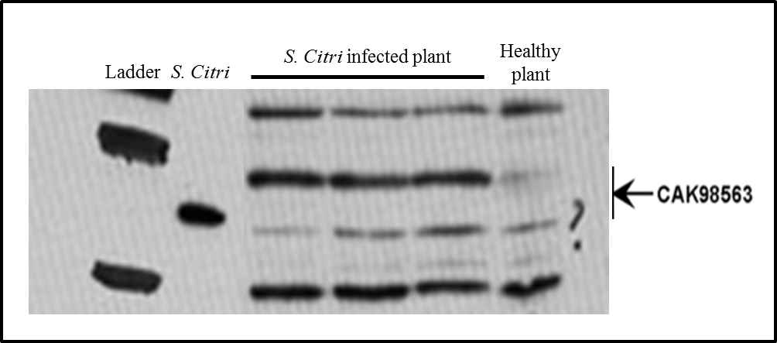
Figure 1. Western blot detecting the CAK98563 S. citri secreted protein in graft-inoculated citrus plants. Proteins extracted from S. citri cells were used as a positive control. Arrow indicates the position of CAK98563 based on its predicted molecular weight.
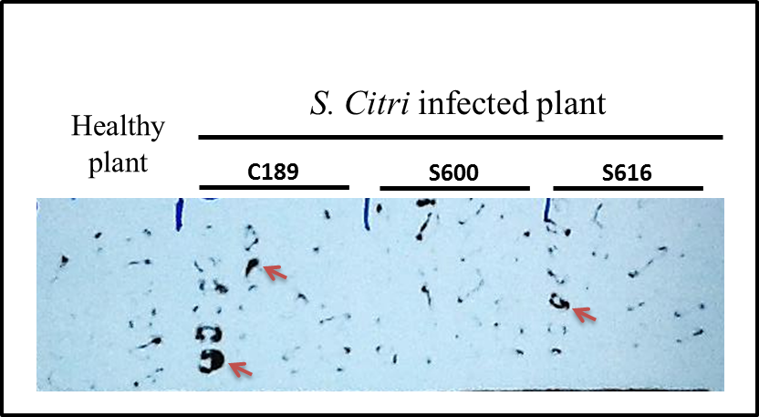

Figure 2. Direct plant tissue imprint detecting the CAK98563 S. citri secreted protein in graft-inoculated citrus plants. Stem section were printed on membranes, which were then incubated with the ScCCPP1 antibody. Stem imprints show positive signals from S. citri graft-inoculated infected trees. Positive signals (arrows) are present in the regions corresponding to the phloem-rich tissues (bark) of a branch, where the bacterium, and presumably the CAK98563 protein should be located. In this specific imprint healthy tissue also shows some positive signal.

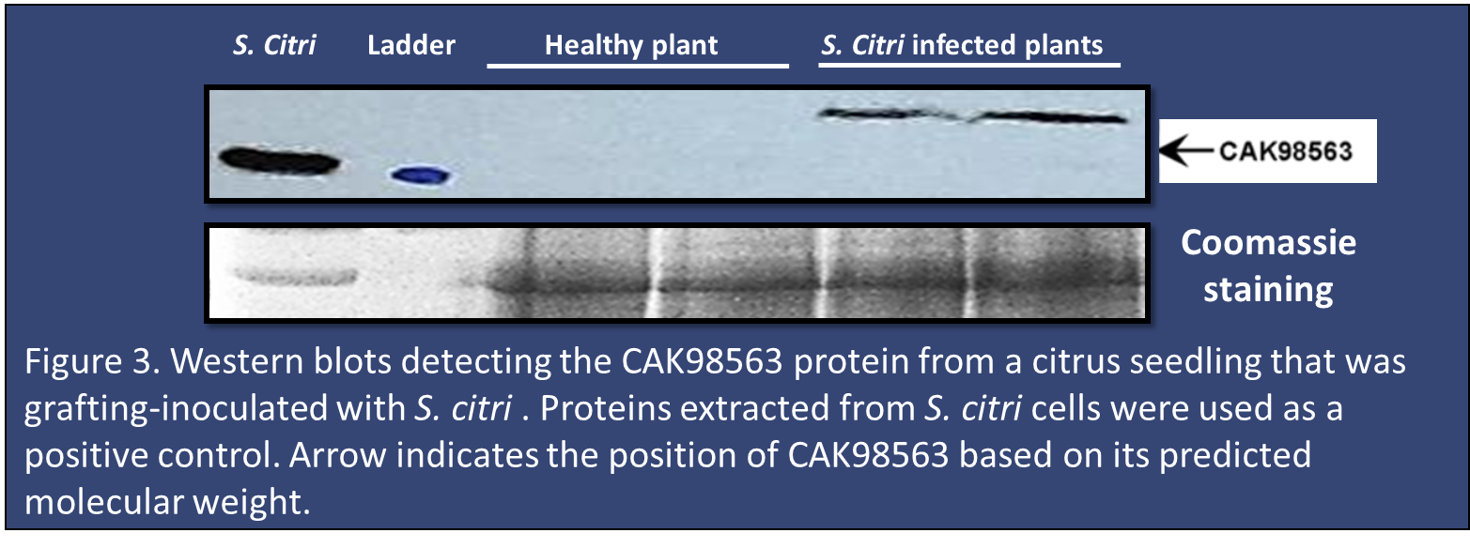

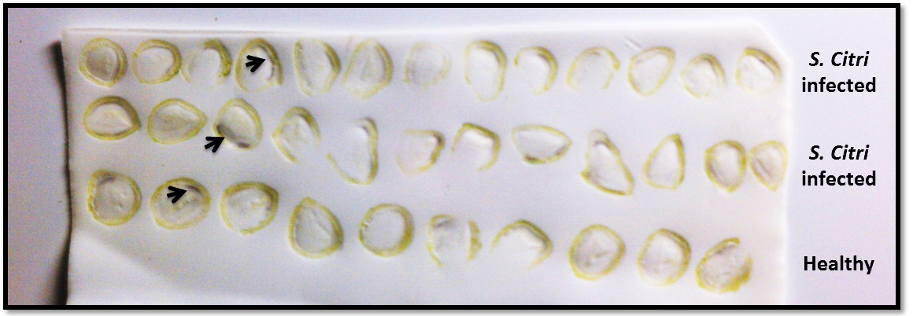

Figure 4. Direct plant tissue imprint detecting the CAK98563 S. citri secreted protein in graft-inoculated citrus plants. Stem section were printed on membranes, which were then incubated with the ScCCPP1 antibody. The binding of the antibodies with their target protein was detected by incubating the membrane in chromogenic-color producing substrate. Positive signals (arrows) are present in the regions corresponding to the phloem-rich tissues (bark) of a branch, where the bacterium, and presumably the CAK98563 protein should be located. In these specific imprints healthy tissue also shows some positive signal.

Results Objective 2. Develop an ELISA essay using the S. citri secreted protein antibodies.
This objective was not part of the last year proposal and was included later on as alternative and/or additional technique to the direct tissue imprint essay.

As indicated above, preliminary results from the use of the ScCCPP1 polyclonal antiserum with the direct tissue imprint essay have indicated that some non-specific signal, probably due to nonspecific binding of the antiserum, occurred in some non-infected tissues. To address the issue, we investigated the use of alternative immunological detection techniques and developed an ELISA essay using purified ScCCPP1 antibody. The preliminary results on the indirect ELISA essay are promising (Figure 5) and we will continue to work on this method to optimize the protocol and standardize the results.
ELISA is a powerful, quick and simple method for detecting and quantifying a specific protein in complex mixtures. ELISA is designed to rapidly handle large numbers of samples, therefore is ideal for the citrus industry, growers and nurseries. Compare to the imprint essay, this technique will allow separation of specific ScCCPP1 antibody-CAK9856 protein binding from nonspecific, background interactions via serial binding to a solid surface (polystyrene multiwell plate). The result will be a quantitative readout that correlates to the amount of CAK9856 protein present in the original sample.

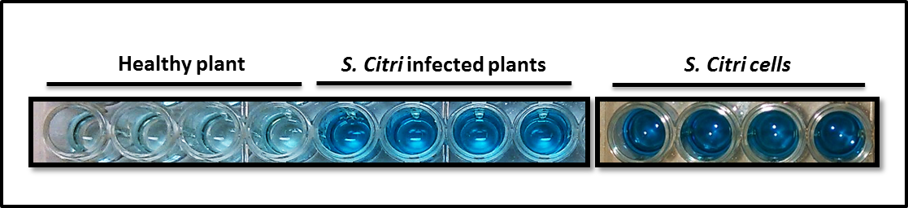

Figure 5. A microtiter plate used to test plant samples for Spiroplasma citri using indirect enzyme-linked immunosorbent assay (ELISA). Each sample was loaded 4 times. A color change (dark blue wells) indicates that the tissue samples tested positive for CSD, whereas negative samples remain colorless.

Results Objective 3. Validate a bioimaging assay using confocal laser scanning microscopy and DNA-sensitive fluorescent dyes to detect Spiroplasma citri cells in the sieve tubes in the phloem of infected plant.

We have carried additional studies using confocal laser scanning microscopy utilizing DNA-sensitive fluorescent dyes (Figure 6). In order to visualize S. citri cells in the phloem sieve tubes of graft-inoculated and mechanically-inoculated citrus, we used DNA-sensitive fluorescent dyes, which will stain live and/or dead bacterial cells. Three dyes were used to track the S. citri cells: Dye #1 stain cell membranes with a high membrane potential therefore identifies live cells; Dye #2 stains DNA and reacts with both viable and dead (or inactive) bacterial cells; and Dye #3 stains the callose in the phloem tissue, and therefore provides a reference point for the location for the S. citri cells. A confocal laser scanning microscope (Leica TCS SP5) equipped with an argon ion laser at UC Riverside core facilities were used to detect the fluorescence signals from these three dyes in S. citri infected and healthy plant tissues. This technique, will allow us to track the movement and location (no other technique does that) of live and/or dead S. citri cells in plant tissue from citrus plants infected with S. citri.
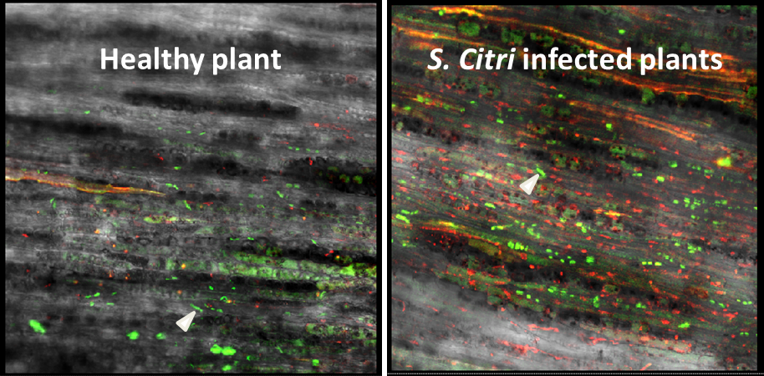

Figure 6. Localization of S. citri in the citrus phloem with DNA staining dye #2 (reacting with both viable and dead (or inactive) bacterial cells) using two channel confocal laser scanning microscopy. Longitudinal section of infected citrus were stained with dye #2 (red) and aniline blue (green). The sieve plates (arrow head) in the phloem tissue fluoresce green. There is strong dye #2 fluorescence (red) in the phloem tissue (sieve plates in green) indicating S. citri infection.

Results Objective 4. Test and validate the DNA-binding dye, propidium monoazide (PMA), in conjunction with quantitative polymerase chain reaction (PMA-qPCR) to detect live S. citri cells in plant tissue samples.

Currently under testing and will be validated by December 2014. PMA is a highly selective DNA-intercalating dye with azide groups that binds to DNA of dead cells only upon exposure to bright light and, thus, renders the DNA insoluble during DNA extraction and undetectable by PCR. In the past two years we developed a TaqMan q-PCR assay and tested extensively greenhouse and field citrus samples. PMA will be used in combination with our established TaqMan qPCR assay to only detect the DNA extracted from live cells. We will be able to detect the genomes of live bacteria in a given sample but also the total genome present by qPCRing PMA-treated and -untreated samples as described above.

