Project title/description: Development of rapid, field-deployable diagnostic assays for detection of all species of huanglongbing-associated Liberibacters.
Project leader: Dr. Chandrika Ramadugu
Progress report for year 1 (2015):
The current project has two main aims: a) to design a dipstick assay for easy, inexpensive detection of citrus Liberibacter and b) to develop universal detection assays for all Liberibacters pathogenic to citrus. We have made some modifications to our original plan. As a model system for developing a test dipstick assay, we decided to use the tomato Liberibacter system instead of CTV. Secondly, we have decided to pursue the antibody approach for building the dipsticks for detection of Las since this will be better than the nucleotide approach for technical reasons and for the convenience of the end-user.
Objectives specified in the original proposal:
- Develop the methodology for dipstick detection using CTV as a model system
- Identify genomic regions conserved in all known Liberibacters associated with citrus and analyze their suitability to amplify bacterial DNA from relevant Liberibacters but not from other members of the Rhizobiaceae.
- Develop nucleic acid-based dipsticks for detection of citrus Liberibacters.
- Conduct field evaluations of dipsticks (both CTV and HLB dipsticks).

Modified objectives:

- Develop the methodology for nucleic acid-based dipstick detection using tomato Liberibacter as a model system. (Objective is fulfilled)
- Identify conserved nucleotide sequences in related Liberibacters and evaluate by qPCR analysis. Develop dipsticks for universal detection of all relevant Liberibacters. (Primer evaluation is almost completed. Although they function well in qPCR assays, they are not suitable for development of dipstick assays).
- Identify proteins conserved in relevant Liberibacter species associated with citrus by gene expression analysis. Clone the corresponding genes, express proteins in bacteria and generate antibodies. (Have conducted gene expression analysis and cloning of target genes. Protein expression is now in progress).
- Raise polyclonal antibodies for the selected proteins and develop protein-based dipsticks for detection of citrus Liberibacters. (To be done in year 2)
- Conduct evaluations of dipsticks using psyllid and plant samples. (Will be done in year 3).

Summary of progress made during year 1:

a). As a proof of concept, a DNA-based dipstick assay was developed for detection of Liberibacter from the tomato pathosystem.
b). We have conducted bioinformatics analysis and compared whole genome sequences of five Liberibacters and identified regions present only in Liberibacters but absent from other Rhizobiaceae members. Primers designed for these regions were successful in qPCR assays and amplified many known Liberibacters that are closely related to the citrus pathogen.
c). A primer array with 384 primer pairs was constructed and utilized to analyze 384 different Liberibacter (Las) genes.
d). Expression of 384 selected genes in HLB positive plants and psyllids was analyzed by real time PCR.
e). Four candidate genes that are present on the bacterial surface and expressed at very high levels were selected for further studies.
f). The four candidate genes were amplified by PCR and cloned in suitable plasmid vectors. Expression of the four proteins in bacterial expression systems is currently in progress.
Antibody production will follow next year. We will design dipsticks with the polyclonal antibodies raised to Las surface proteins.
Ideally, dipstick assays should be designed using monoclonal antibodies since these will provide uniformity and reliability. We will seek separate funding for generating monoclonal antibodies.

Work plans and Methods:
Objective 1.
1a. Brief task objective: Our original ‘objective one’ was to develop a method for dipstick detection of CTV as a model system. We have modified objective one to include the tomato Liberibacter that is closely related to the citrus Liberibacter. Instead of developing a method to detect CTV, we have developed nucleic-acid based dipstick assay to detect the tomato Liberibacter. Since the second goal of this study was to develop universal primers that are capable of detecting all Liberibacters, using the tomato Liberibacter as a model organism was considered more appropriate.

1b. Activities and methods description:
The protocols consisted of: a) Designing primers for detection of tomato Liberibacter by isothermal amplification (figure 2). b) Amplification of Liberibacters from psyllids (figure 1, 3). c) Building dipstick units using materials suitable for the sample pad, conjugate pad, nitrocellulose layer and absorbent pad (to function as a wick at the distal end; figure 4a). d) Conducting the assays with the home-made unit (figure 4a). e) Repeating the assays using a commercially available dipstick (figure 4b).

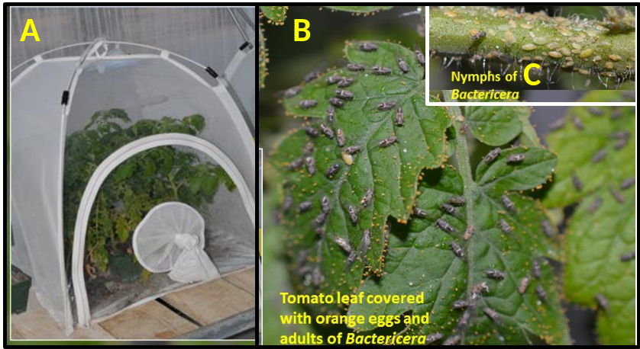
Figure 1. The potato psyllid, Bactericera cockerelli carries the tomato Liberibacter which is very similar to the citrus Liberibacter. Figure 1 shows a bugdorm with infected tomato plant (A), a close up of tomato leaves covered with eggs and adults (B) and a stem piece with psyllid nymphs (C).

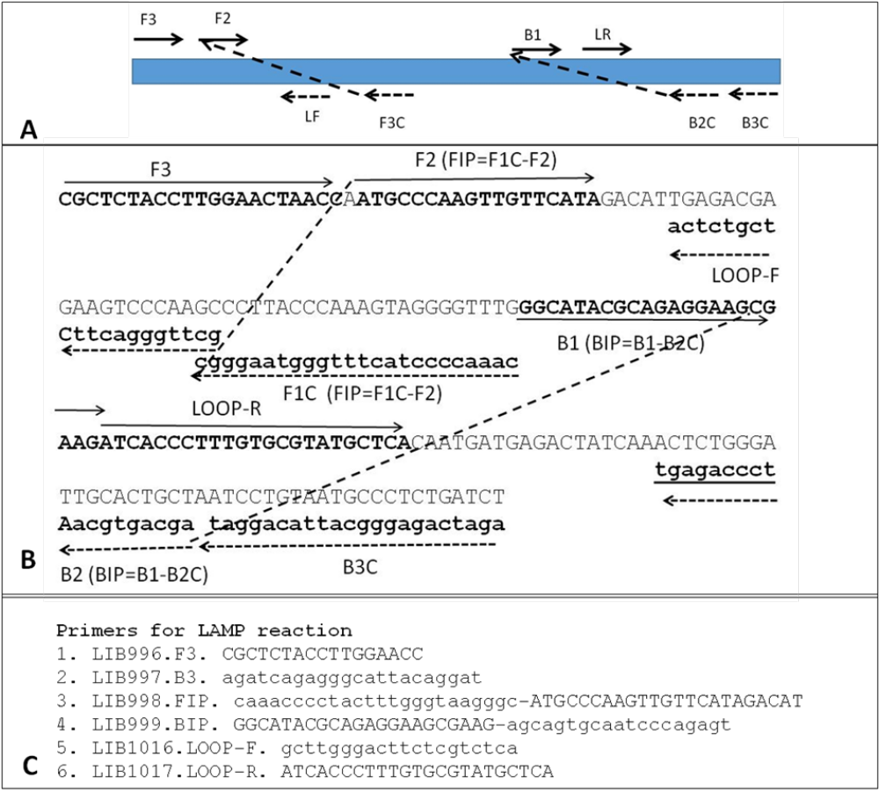
Figure 2. Design of LAMP (loop-mediated amplification method) primers for amplification of a phage related gene from the tomato Liberibacter at ambient temperatures. Primer explorer v4 software was used to design four primers; two other primers were designed manually. LAMP utilizes six primers that recognize six sequences resulting in high specificity. The reaction is initiated by the inner primers (FIP, BIP). Outer primers F3 and B3 initiate synthesis of complementary sequence that displaces DNA extended from the inner primer. The auto-primed dumb-bell like structure is the starting material for LAMP. The loop primers hybridize to sections of the loop and improve selectivity. As depicted in the diagram, this complex primer design is not feasible for all genomic regions.
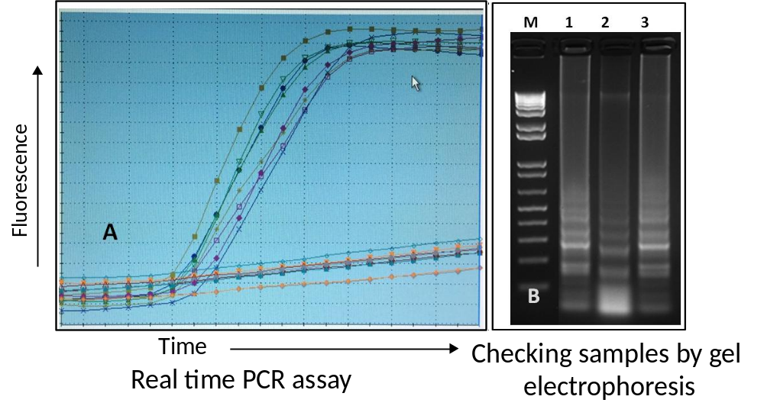
Figure 3. Amplification of the target gene from tomato Liberibacter by using newly designed LAMP primers. Panel A shows amplification of positive samples in real time PCR assays. Panel B shows characteristic ladder-like amplification products of the LAMP reaction on a 2% agarose gel. Lane M has molecular weight markers; lanes 1,2,3 have amplification products of LAMP reaction.

A B
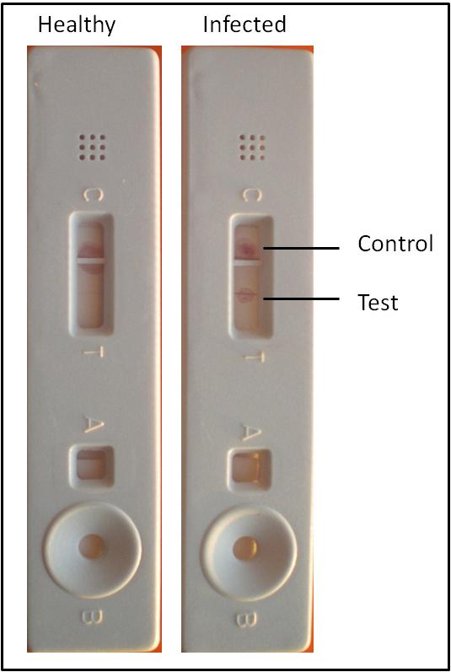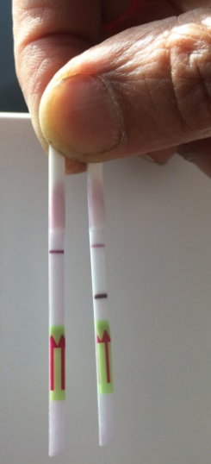
Figure 4. Nucleic-acid based detection test developed for the tomato Liberibacter. Panel A shows a home-made dipstick with negative and positive reactions from healthy and infected psyllid samples. Panel B shows a similar test conducted using strips purchased from a commercial entity. The target gene from the tomato psyllid is amplified using LAMP primers and placed on the sample port B shown at the bottom of the home made dipstick strip in panel A. To get sharp bands as seen in panel B, we will need specialized equipment for assembling the layers of the dipstick. Commercially available dipstick that already has generic antibodies impregnated on the dipstick (panel B) gives clear signals with our amplification product.
1c. Task products and estimated completion dates: We have completed the dipstick assay for the model organism, tomato Liberibacter. We have obtained proof of concept for the dipstick assay using nucleic acid-based testing. However, since we are using a commercial dipstick strip, the cost of each assay will be about $15.00.

Objective 2.
2a. Brief task objective: Identify genomic regions conserved in all known Liberibacters associated with citrus, design primers and evaluate the primers by qPCR analysis to assess their suitability in detection of HLB pathogens.

2b. Activities and methods description: We want to select genomic segments that are conserved in all citrus-associated Liberibacters. The genome of Liberibacters is about 1.2 million bases and contains about 1100 genes. At present, we have genome information available for several isolates of CLas, two isolates of CLam, one isolate of CLso (Zebra chip disease of potato) and Lcr (Liberibacter crescens, the only species of Liberibacter that has been cultured). Since genomic information of Ca. L. caribbeanus and other variants of Liberibacter suspected to be present in citrus relatives is not yet available, analysis of other closely related Liberibacters is useful in designing primers that may be capable of amplifying DNA from all relevant Liberibacters.
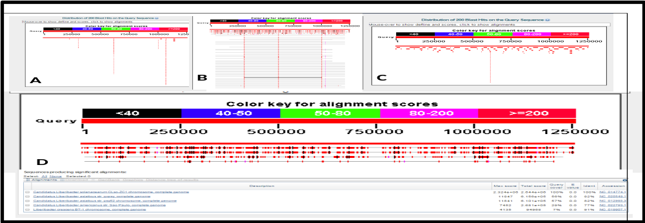
Figure 5. Blast analysis of complete genomes of the Ca. Liberibacter asiaticus, Ca. L. americanus (two strains), Ca. L. solanacearum (very similar to the tomato pathogen) and Liberibacter crescens. Solid red bars represent regions of identity. Gaps represent regions with sequence variability.
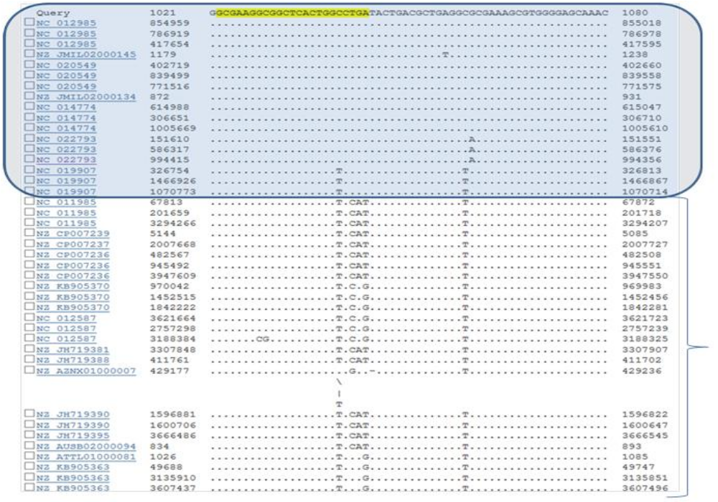
Figure 6. Comparison of nucleotide sequences of different related bacterial genomes revealed that certain regions are common to only Liberibacters and not present in other members of Rhizobiaceae. The boxed region at the top represents Liberibacter sequences and the region at the bottom is obtained from other members of Rhizobiaceae.

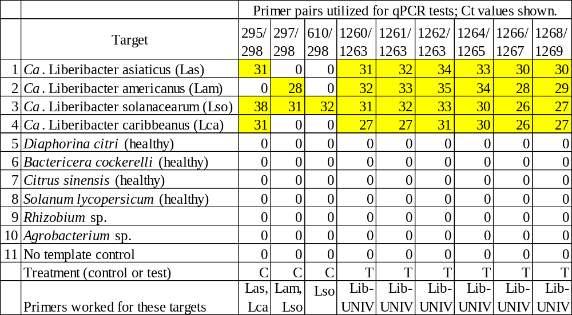
Figure 7. Primers designed for the unique regions of Liberibacter genomes are successful in qPCR amplification method as shown in this table. Highlighted cells indicate a positive qPCR reaction. The primer pairs used are indicated by primer numbers at the top of the columns.
For objective two, we have compared the genomes of known Liberibacters by blast analysis (figure 5), selected regions of the genome where Liberibacters have unique sequences (figure 6) and validated the qPCR assays using pathogen DNA extract (figure 7).
2c. Task products and estimated completion dates: We have completed the bioinformatics analysis for selection of regions suitable for qPCR analysis. Preliminary qPCRs were conducted using purified DNA extractions of different Liberibacters. In year 2, we will evaluate the qPCRs using plant and psyllid samples.
Objective 3.
3a. Brief task objective: Identify proteins conserved in relevant Liberibacter species associated with citrus by gene expression analysis. Clone the corresponding genes, express proteins in bacteria and generate antibodies.

3b. Activities and methods description: The primers selected by the bioinformatics analysis (described under objective 2) are functional in qPCR analysis. LAMP primers are difficult to design for all regions of the genome. After a lot of effort, we have concluded that the unique regions that could be amplified in qPCR assays are not suitable for LAMP reactions. We have decided that it would be best to use antibody-based assays for the dipsticks. Antibofy-based dipstick technology is well established in point of need testing procedures. In order to select proteins suitable for making antibodies, we have done the following:
a). Designed primers for 384 LAS genes
b). The primer pairs were synthesized in four 96 well plates (services of IDT DNA)
c). The genes selected code for membrane proteins, secreted proteins, intracellular proteins and phage related proteins. Intracellular proteins represent various metabolic pathways (selections based on in-depth bioinformatic analysis).
d). RNA extractions were made from both Las-infected insects and plants (conducted in Florida).
e). cDNA was synthesized and used for analysis of expression levels of selected genes by real time PCR (figures 8 a, b, c, d).
f). The goal is to identify suitable genes that are expressed at very high levels. Surface proteins were chosen to facilitate direct detection of bacteria in psyllids (and plants)
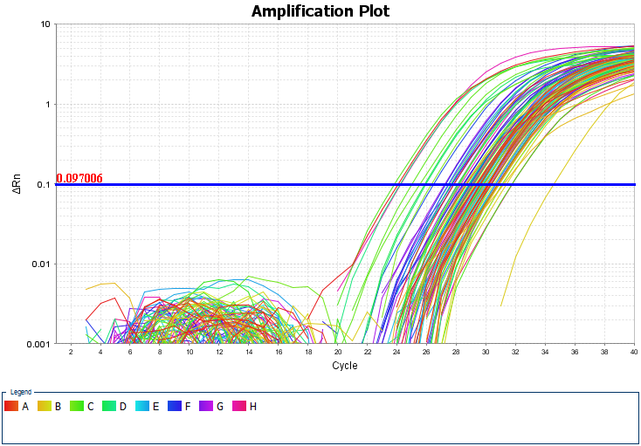
Figure 8a. Expression patterns of genes 1-96
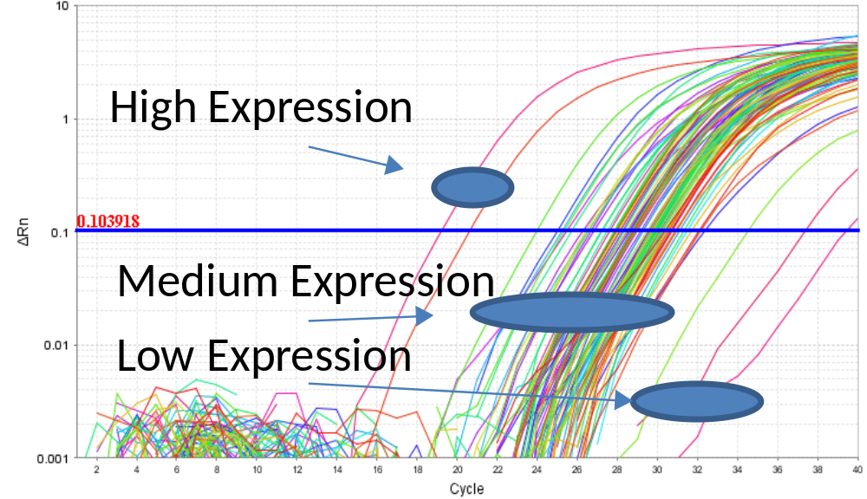
Figure 8b. Expression patterns of genes 97-192
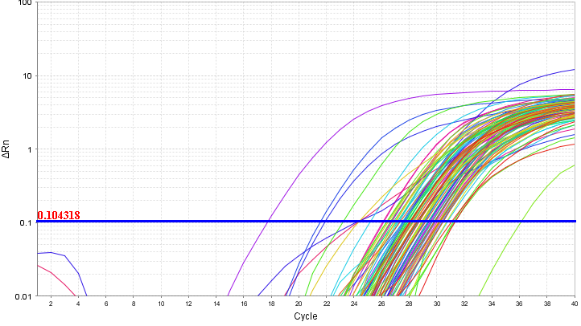
Figure 8c. Expression patterns of genes 193-288
Figure 8d. Expression patterns of genes 289-384
3c. Task products and estimated completion dates.
We will complete this part of the assay by the end of the first year. We have cloned the candidate genes in suitable vectors. Protein expression is in progress (Clontech). During year 2 we will complete the protein expression and raise four different polyclonal antibodies. The antibodies will be evaluated for their suitability in detection assays.

Objective 4.
4a. Brief task objective: Raise polyclonal antibodies for the selected proteins and develop protein-based dipsticks for detection of citrus Liberibacters. (To be done in year 2)

4b. Activities and methods description. Polyclonal antibodies will be evaluated using psyllid and plant extracts. Suitable antisera will be used for dipstick assays.
4c. Task products and estimated completion dates: Will be completed in year 2 of the project.
Objective 5.
5a. Brief task objective: Conduct evaluations of dipsticks using psyllid and plant samples. (Will be done in year 3).
5b. Activities and methods description: Field collected samples of psyllids and plants will be used for evaluation of dipsticks. We will conduct these tests in Florida (when we travel to Florida to conduct other projects).
5c. Task products and estimated completion dates: Will be completed in year 3.

