Project title/description: Development of rapid, field-deployable diagnostic assays for detection of all species of huanglongbing-associated Liberibacters.
Project leader: Dr. Chandrika Ramadugu
Progress report for year two (2016):
The current project has two main aims: a) to design a dipstick assay for easy, inexpensive detection of citrus Liberibacter and b) to develop universal detection assays for all Liberibacters pathogenic to citrus. We have made some modifications to our original plan. As a model system for developing a test dipstick assay, we decided to use the tomato Liberibacter system in addition to CTV. Secondly, we have decided to pursue the antibody approach for building the dipsticks for detection of Las since this method will be superior to the traditional PCR-based approach for technical reasons and for the convenience of the end-user.
Modified objectives (as stated in year 2):

1. Develop the methodology for nucleic acid-based dipstick detection using tomato Liberibacter as a model system (completed). Develop dipsticks for detection of CTV using anitbodies available in the lab (a homemade assay completed and commercial assay under development).
2. Identify conserved nucleotide sequences in related Liberibacters and evaluate by qPCR analysis. Develop dipsticks for universal detection of all relevant Liberibacters. (Primers designed work well in qPCR assays; development of loop-mediated amplification assays is still in progress).
3. Identify proteins conserved in relevant Liberibacter species associated with citrus by gene expression analysis. Clone the corresponding genes, express proteins in bacteria and generate polyclonal antibodies (this aspect is completed). Develop dipstick assays (to be done in year 3).
4. Raise monoclonal antibodies for Liberibacter surface antigens in AuCoin laboratory. Evaluate monoclonals and develop protein-based dipstick assays for detection of citrus Liberibacters (to be done in year 3). This objective has been added in year 3 since our discussions with AuCoin made us aware of the possibility of having better success with this approach.
5. Conduct evaluations of dipsticks using psyllid and plant samples (will be done towards the end of year 3).
Summary of progress made during years 1 and 2:

a). As a proof of concept, a DNA-based dipstick assay was developed for detection of Liberibacter from the tomato pathosystem (Figure 1). We have also developed home-made dipsticks for CTV (Figure 2; manuscript submitted for publication. Maheshwari et al., 2016). Dr. Aucoin recommended that commercial quality dipsticks can be made by them if we used a combination of a polyclonal and a monoclonal antibody. Since monoclonal antibodies can be used for highly reproducible results, we have now rejuvenated an old cell line that was made by Keremane and Lee (1995) (and stored in the hybridoma core facility, University of Florida, Gainesville) and purified IgG from this monoclonal antiserum. This monoclonal antibody as been evaluated against multiple CTV isolates in several locations and shown to detect a wide range of CTV isolates. The purified preparation will be used to generate CTV dipsticks using the services of DxDiscovery company (University of Nevada school of Medicine Biotech startup company; collaboration with AuCoin).

b). We have conducted bioinformatics analysis and compared whole genome sequences of five Liberibacters and identified regions present only in Liberibacters but absent from other Rhizobiaceae members. Primers designed for these regions were successful in qPCR assays and amplified many known Liberibacters that are closely related to the citrus pathogen (Figure 3). We are in the process of developing LAMP assays using the data generated.

c). A primer array with 384 primer pairs was constructed and utilized to analyze 384 different Liberibacter (Las) genes. Expression of 275 selected genes in HLB positive plants and psyllids was analyzed by real time PCR. These genes were selected based on the predicted location of the relevant proteins in the bacterial cell (in-silico prediction), and their probable antigenicity properties. RNA from infected plants was used to reverse-transcribe. Complementary DNA was used for qPCR based analysis of gene expression in infected plant materials. We selected three candidate genes (named UCR 1, UCR 2 and UCR 3) for further studies. These genes code for proteins that are present on the bacterial surface and are expressed at very high levels in infected plant tissue.

d). The three candidate gene fragments were amplified by PCR and cloned in suitable plasmid vectors. Expression of the three Liberibacter proteins in bacterial expression systems has been completed. Polyclonal antisera were raised for the three expressed proteins in rabbits. Western blots conducted using an anti-His monoclonal antibody showed a strong expressed protein in all three bacterial clones (Figure 4). We will design dipsticks with the polyclonal antibodies raised to Las surface proteins with the help of AucCoin lab and DxDiscovery company.
Ideally, dipstick assays should be designed using monoclonal antibodies since these will provide uniformity and reliability. Further hybridoma cells producing these monoclonal antibodies can be stored forever, they are eternal sources of antibodies of the same quality. As an example, we have revived a hybridoma cell line stored in Florida in 1995 to develop CTV dipsticks as a proof of concept. We have now started collaboration with David AuCoin’s group (Nevada) since they have successfully developed monoclonal antibodies and dipsticks to many human pathogens (both culturable and unculturable types).

A B
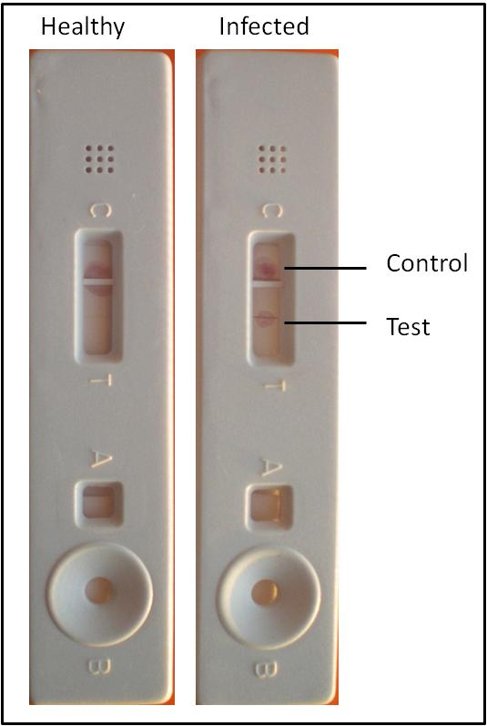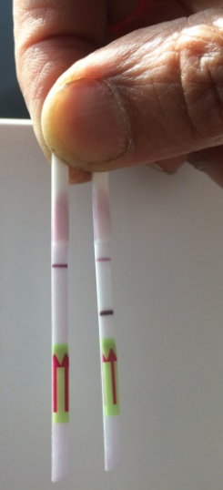
Figure 1. Nucleic-acid based detection test developed for the tomato Liberibacter. Panel A shows a home-made dipstick with negative and positive reactions from healthy and infected psyllid samples. Panel B shows a similar test conducted using strips purchased from a commercial entity. The target gene from the tomato psyllid is amplified using LAMP primers and placed on the sample port B shown at the bottom of the home made dipstick strip in panel A. To get sharp bands as seen in panel B, we will need specialized equipment for assembling the layers of the dipstick. Commercially available dipstick that already has generic antibodies impregnated on the dipstick (panel B) gives clear signals with our amplification product.

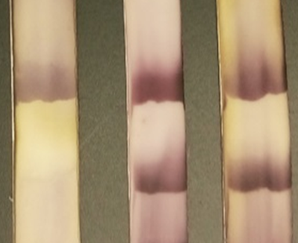
Figure 2. Evaluation of CTV antibody (IgG purified from a polyclonal antibody) in lateral flow immunoassay using different strains of CTV. Lane 1: Healthy plant extract. Lane 2: extract from plant infected with VT strain of CTV. Lane 3: extract from plant infected with RB strain of CTV. Control line (top) and test line (bottom) are shown. From Maheshwari et al. 2016; manuscript submitted for publication.

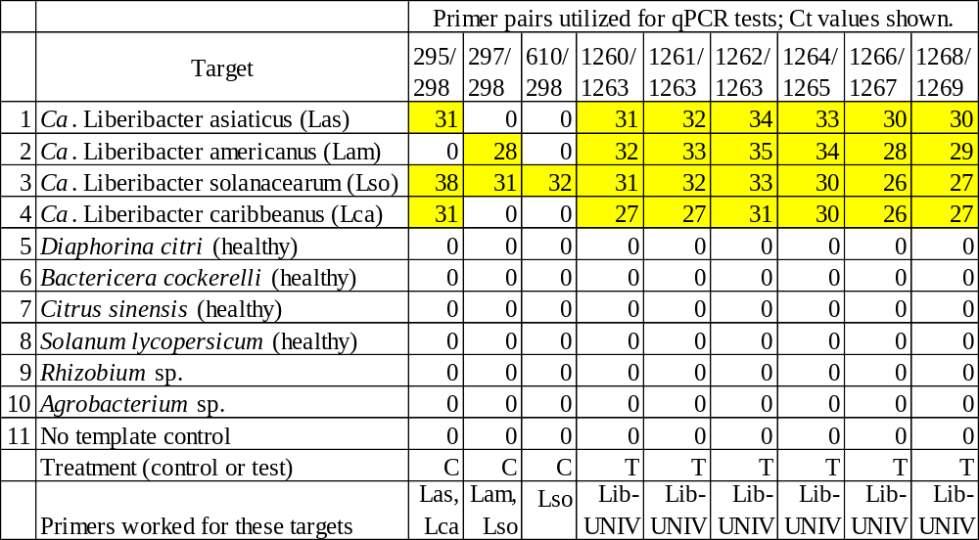
Figure 3. Primers designed for the unique regions of Liberibacter genomes are successful in qPCR amplification method as shown in this table. Highlighted cells indicate a positive qPCR reaction. The primer pairs used are indicated by primer numbers at the top of the columns.

